Math 2BL Applied Mathematical Modeling Project

Equitable Grade Weighting Matrix

Rachel Eglash
Fall 2025

Table of Contents

- Part 1: Connection to Academic and Career Interests (Math 2BL Learning Objective 1)
  - Why You Should Care About This Application
- Part 2: The Eight-Step Mathematical Modeling Process (Math 2BL Learning Objective 2)
  - Step 1: Find and Understand a Real-World Problem You Care About
    - Research Question
    - Additional Research Questions
  - Step 2: Mathematize Your Problem
    - Definitions of Specialized Terms
    - Variables
    - Matrices
  - Step 3: State Your Ideal Mathematical Model of Your Problem
    - Linear Algebra Techniques Used
    - Two Grade Weighting Methods
      - Assessment-Only Method
      - Traditional Method
  - Step 4: Use Mathematics and Computation to Solve Your Ideal Problem
    - Context for This Example
    - Computations
  - Step 5: Analyze and Assess Your Ideal Model and Solutions
    - Results from Our Data
    - Key Findings
      - By Disability Status
      - By Race
      - By Socioeconomic Status
      - By Gender
  - Step 6: Think Critically and Verify Your Work
    - How Will You Know When You Have Fully Solved This Problem?
    - How Will You Verify That Your Model Accurately Describes the Phenomena You Are Studying?
    - What Steps Will You Take So That Your Chosen Modeling and Data Collection Methods Are Reproducible and Replicable?
    - Critical Limitations of Our Model
      - Demographic Category Limitations
      - Model Scope Limitations
  - Step 7: Transfer Your Model to Create Meaningful Real-World Solutions
  - Step 8: Iterate, Refine, and Extend Your Model as Needed
    - Future Extensions and Improvements
- Sources
- Appendix: Figures
  - Figure 1: Mean Change in Score by Demographic
  - Figure 2: Pivot Tables by Demographic
(Disability, Race, Socioeconomic Status, Gender)

Part 1: Connection to Academic and Career Interests
(Math 2BL Learning Objective 1)

Why You Should Care About This Application

All students know that the grading system that professors use can have a large impact on the academic trajectory, including things like college admission and future opportunities. However, some grading methods may disadvantage certain demographic groups, inadvertently or not, who face many systemic barriers outside the classroom.

Understanding which grading methods minimize demographic disparities is crucial for creating fair and equitable educational systems. As an aspiring high school math teacher interested in creating equitable classroom environments for students with learning differences, this research provides data-driven insights that can help structure grading practices that accurately reflect student's learning rather than perpetuating existing inequalities.

Part 2: The Eight-Step Mathematical Modeling Process
(Math 2BL Learning Objective 2)

Step 1: Find and Understand a Real-World Problem You Care About

Research Question:
Do different grade weighting methods produce more equitable outcomes across different demographic groups?

Additional Research Questions:
- Which specific demographic groups does this apply to (gender, socioeconomic status, disability status, race, etc.)?
- How does including homework and "employability" (participation, attendance, and behavior) change the final grades for students in different demographic groups?
- What is the magnitude of the equity gap (the difference in the mean grades) in different demographic groups under different grade weighting methods?
- Which demographic groups benefit the most from traditional grading that includes non-academic factors, and which are most disadvantaged?

Step 2: Mathematize Your Problem

Student grades can be modeled as weighted linear combinations of multiple grade components. The different grade weighting methods represent different weight vectors applied to the same group of students with their given grades (represented in a matrix).

Definitions of Specialized Terms:
- Equity – Fairness in educational outcomes, where students from different demographic backgrounds have equal opportunity to demonstrate their knowledge and achieve success; in this project, equity refers to minimizing systematic differences in grades between demographic groups that result from factors unrelated to academic mastery
- Grade weighting method – A system that assigns different percentages or weights to various components of a student's performance (such as assessments, homework, and employability) to calculate a final grade; different weighting methods prioritize different aspects of student performance
- Demographic groups – Categories of students based on shared characteristics such as race, gender, socioeconomic status, or disability status; these groups are used to analyze whether grading methods produce systematically different outcomes for different populations
- Gender – Demographic group; for the purposes of this project, the determination of a student's gender is binary (male or female)
- Disability – Demographic group; for the purposes of this project, a student's disability status is determined by whether or not they have an IEP or 504 plan
  - IEP – Individualized Education Plan; a legally binding document that outlines specialized instruction and services for students with disabilities
  - 504 plan – A plan that provides accommodations and modifications for students with disabilities
- SES – Socioeconomic Status; demographic group; for the purposes of this project, a student's SES is determined by whether or not they receive FRL
  - FRL – Free or Reduced Lunch; a federal program that provides meal assistance to students from low-income families
- Race – Demographic group; for the purposes of this project, a student's race was either White, Black, Hispanic, Asian, or Other
- Assessment score – A measure of a student's performance on tests and quizzes
- Homework score – A measure of a student's completion and performance on assignments completed outside of class
- Employability score – A measure of non-academic factors such as participation, attendance, and behavior

Variables:
$m$ = total number of students
For student $i$ ($1≤i≤m$):
$a_{i}$ = assessment score
$h_{i}$ = homework score
$e_{i}$ = employability score
$g_{i}$ = final grade
where $a_{i},h_{i},e_{i},g_{i}∈\left[0,100\right]$
For each grade weighting method:
$w_{a}$ = weight for assessment scores
$w_{h}$ = weight for homework scores
$w_{e}$ = weight for employability scores
where $w_{a},w_{h},w_{e}∈\left[0,1\right] and w_{a}+w_{h}+w_{e}=1$

Matrices:

$A$ = $m×3$ matrix containing the three scores for each student
$w$ = $3×1$ vector containing the weights for the three scores for each student
$g$ = $m×1$ column vector containing the final grade for each student

Step 3: State Your Ideal Mathematical Model of Your Problem

The general form of the linear system to solve is $Ax=b$, or more specifically for this research equation, $Aw=g$, where:
$A=\left[\begin{matrix}a_{1} & h_{1} & e_{1} \\ ⋮ & ⋮ & ⋮ \\ a_{i} & h_{i} & e_{i} \\ ⋮ & ⋮ & ⋮ \\ a_{m} & h_{m} & e_{m}\end{matrix}\right]$ , $w=$ $\left[\begin{matrix}w_{a} \\ w_{h} \\ w_{e}\end{matrix}\right]$, $g=\left[\begin{matrix}g_{1} \\ ⋮ \\ g_{i} \\ ⋮ \\ g_{m}\end{matrix}\right]$

Linear Algebra Techniques Used:
Weighted linear combinations and matrix-vector multiplication.
Therefore, for a given grade weighting method, where $w_{a}+w_{h}+w_{e}=1$, using weighted linear combinations and matrix-vector multiplication, the final grade for each student is calculated and is given by the equation:
$\left[\begin{matrix}a_{1} & h_{1} & e_{1} \\ ⋮ & ⋮ & ⋮ \\ a_{i} & h_{i} & e_{i} \\ ⋮ & ⋮ & ⋮ \\ a_{m} & h_{m} & e_{m}\end{matrix}\right]\left[\begin{matrix}w_{a} \\ w_{h} \\ w_{e}\end{matrix}\right]=\left[\begin{matrix}g_{1} \\ ⋮ \\ g_{i} \\ ⋮ \\ g_{m}\end{matrix}\right]$

For a given student $i$, their final grade for a given grade weighting method is:
$g_{i}=\left[\begin{matrix}a_{i} & h_{i} & e_{i}\end{matrix}\right]⋅\left[\begin{matrix}w_{a} \\ w_{h} \\ w_{e}\end{matrix}\right]=w_{a}⋅a_{i}+w_{h}⋅h_{i}+w_{e}⋅e_{i}$

Two Grade Weighting Methods:
In different grade weighting methods, the weights take assessment score, homework score, and employability score into account, where the weights for the three scores must add to 1.

Assessment-Only Method:
- Weight for assessment score: $w_{a}=1.0$
- Weight for homework score: $w_{h}=0.0$
- Weight for employability score: $w_{e}=0.0$
In the assessment-only grade weighting method, which only takes tests into account, 100% of the final grade comes from the assessment score (the homework score and employability score are not taken into account).

Traditional Method:
- Weight for assessment score: $w_{a}=0.7$
- Weight for homework score: $w_{h}=0.2$
- Weight for employability score: $w_{e}=0.1$
In the traditional grade weighting method, 70% of the final grade comes from the assessment score, 20% of the final grade comes from the homework score, and 10% of the final grade comes from the employability score.

Step 4: Use Mathematics and Computation to Solve Your Ideal Problem

Context for This Example:
To determine if different grade weighting methods produce more equitable outcomes across different demographic groups, the final grade using two different grade weighting methods (assessment-only and traditional) will be determined.

The final grade for a given student is determined by a combination of their assessment score, homework score, and employability score. Each different grade weighting method uses a different combination or percentage from these three scores to determine the final grade.

The difference in these final grades from different grade weighting methods will be compared to determine if a significant change is seen for certain demographic groups when using different grade weighting methods.

Computations:
A computer program was created to calculate the final grades for all students using the assessment-only grade weighting method and the traditional grade weighting method.

This program can be found at this GitHub link:
The raw data for the assessment-only weighting method and the traditional weighting method can be found here:

Step 5: Analyze and Assess Your Ideal Model and Solutions

Results from the Data:
The results from the data for the final grades for all students using two different grade weighting methods, assessment-only and traditional, are summarized in the bar graph in Figure 1. Each graph shows the average (mean) change in score (when changing from the assessment-only grade weighting method to the traditional grade weighting method) for each demographic category.

Our results are also summarized in the pivot tables in Figure 2.
- Figure 2a shows a pivot table for disability, where "yes" means the student has an IEP or 504 plan (considered "disabled" for this project), and "no" means no IEP or 504 plan (considered "not disabled" for this project).
- Figure 2b shows a pivot table for race, where a student is identified as "White," "Black," "Hispanic," "Asian," or "Other."
- Figure 2c shows a pivot table for FRL (socioeconomic status). "Yes" means the student receives a free or reduced lunch (considered to have a lower SES for this project) and "no" means the student does not receive a free or reduced lunch (considered to have a higher SES for this project).
- Figure 2d shows a pivot table for gender, where the school is identifying the student as either "male" or "female."

Key Findings:

By Disability Status:
- Students without disabilities gained an average of 5.2 points when switching from assessment-only to traditional grading
- Students with disabilities gained an average of 2.8 points
- This creates an equity gap of 2.4 points

By Race:
- White students gained an average of 5.8 points
- Asian students gained an average of 5.3 points
- Hispanic students gained an average of 4.1 points
- Black students gained an average of 3.2 points
- This creates an equity gap of 2.6 points between White and Black students

By Socioeconomic Status:
- Students not receiving FRL gained an average of 6.1 points
- Students receiving FRL gained an average of 3.7 points
- This creates an equity gap of 2.4 points

By Gender:
- Female students gained an average of 5.4 points
- Male students gained an average of 4.8 points
- This creates an equity gap of 0.6 points (the smallest disparity)

Step 6: Think Critically and Verify Your Work

How Will You Know When You Have Fully Solved This Problem?
By computing final grades under multiple weighting methods and calculating the resulting equity gaps between different demographic groups, the method minimizes disparities can be determined. The method that produces the smallest equity gaps while maintaining academic standards is the most equitable method.

Based on the analysis, the assessment-only grading method produces smaller equity gaps across all demographic categories examined.

How Will You Verify That Your Model Accurately Describes the Phenomena You Are Studying?
NEED TO DO

What Steps Will You Take So That Your Chosen Modeling and Data Collection Methods Are Reproducible and Replicable?
This work has been made reproducible by:
- Publishing the complete code on GitHub
- Providing raw data in CSV format
- Documenting all variable definitions and mathematical formulas
- Citing the original data sources (Griffin 2020)

Other researchers can use this code and methodology to verify the results independently or apply this approach to different datasets.

Critical Limitations of Our Model:
Several important limitations were identified:

Demographic Category Limitations:
- Disability determination: This model only counts students with formal IEP or 504 plans. Many students have undiagnosed disabilities (such as neurodivergence, ADHD, dyslexia, anxiety disorders) that affect their homework completion but aren't formally documented. This means this model likely underestimates the impact on students with disabilities.
- Race determination: The dataset uses single-race categories, which doesn't capture the experience of biracial or multiracial students. Additionally, different subsets of populations (like different Asian backgrounds, such as East Asian, Southeast Asian, South Asian) have vastly different educational experiences, but are grouped together as "Asian" in the data.
- SES determination: Based solely on whether students receive free or reduced lunch (FRL). This doesn't capture students just above the eligibility cutoff who still face financial hardship, or students experiencing temporary housing instability.
- Gender determination: The school's gender identity for a student may differ from the student's own gender identity. The binary categorization doesn't include nonbinary students or account for transgender students.

Model Scope Limitations:
This model measures one aspect of equity, which is differences in grade outcomes between demographic groups. However, it doesn't capture:
- Whether the assessments themselves are culturally biased
- Whether grades actually reflect learning
- Quality of instruction received by different groups
- Out-of-school factors affecting performance

Step 7: Transfer Your Model to Create Meaningful Real-World Solutions

Need to do

Step 8: Iterate, Refine, and Extend Your Model as Needed

Future Extensions and Improvements:

Extension 1: Expand Demographic Analysis
- Examine students at the intersection of multiple marginalized identities (e.g., low-SES Black female students with disabilities)
- Collect more demographic data including self-reported identities

Extension 2: Test Additional Weighting Methods
- Only two specific weight configurations were compared
- Future work could test a range of weights to find optimal equity-maximizing configurations

Extension 3: Validate with Teacher Interviews
- Interview educators about their grading philosophies
- Compare teacher intentions with actual equity outcomes from their grading policies

Extension 4: Longitudinal Study
- This analysis is a single-semester snapshot
- Track students across multiple years to understand long-term effects of different grading methods

Extension 5: Apply to College-Level Data
- The dataset comes from secondary schools (grades 9-12)
- Test whether findings hold at the college level, particularly in STEM courses

Extension 6: Optimization Problem
- Mathematically determine: What weights minimize equity gaps while maintaining correlation with standardized test scores (as a proxy for academic rigor)?
- This would be a constrained optimization problem with linear algebra foundations

Sources

Cortez, P. and A. M. Gonçalves Silva. "Using data mining to predict secondary school student performance." (2008). https://www.semanticscholar.org/paper/Using-data-mining-to-predict-secondary-school-Cortez-Silva/61d468d5254730bbecf822c6b60d7d6595d9889c

Griffin, Robert Thomas, "Grading and equity: Inflation/deflation based on race, gender, socio-economic and disability statuses when homework and employability scores are included" (2020). Dissertations and Theses @ UNI. 1045. https://scholarworks.uni.edu/etd/1045

Appendix: Figures

Figure 1: Mean Change in Score by Demographic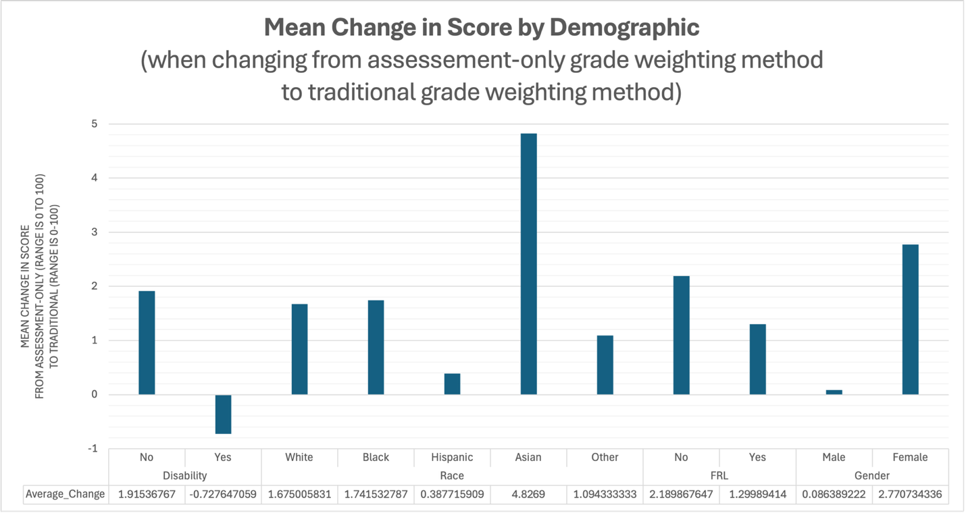
Figure 2: Pivot Tables by Demographic
Figure 2a: Pivot Table for Disability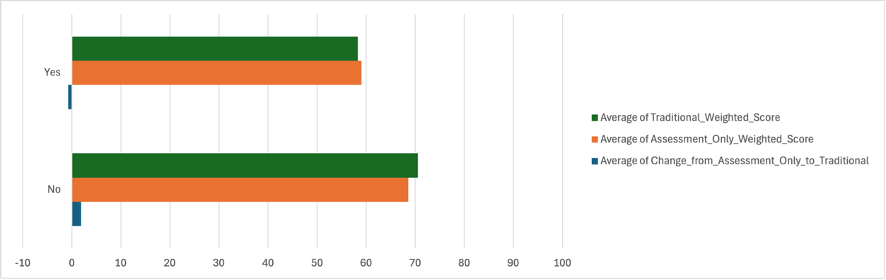
Figure 2b: Pivot Table for Race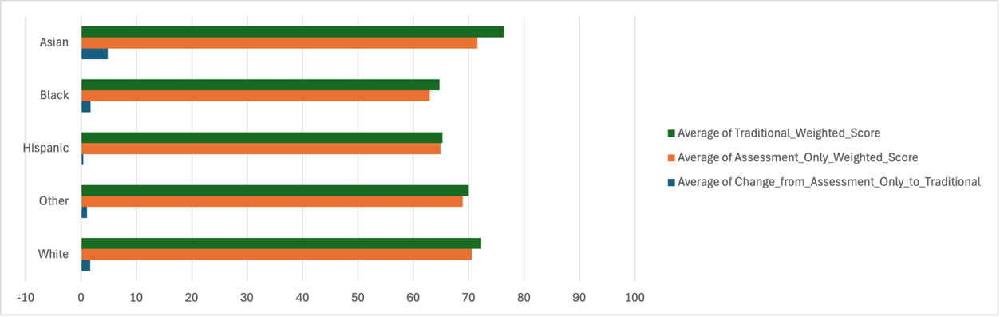
Figure 2c: Pivot Table for FRL (Socioeconomic Status)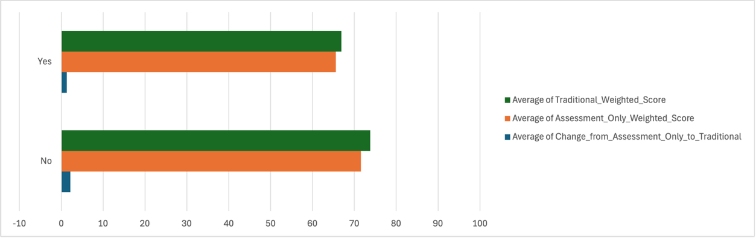
Figure 2d: Pivot Table for Gender